**Definition: Design backgrounds in Figma.**

**Solution:**

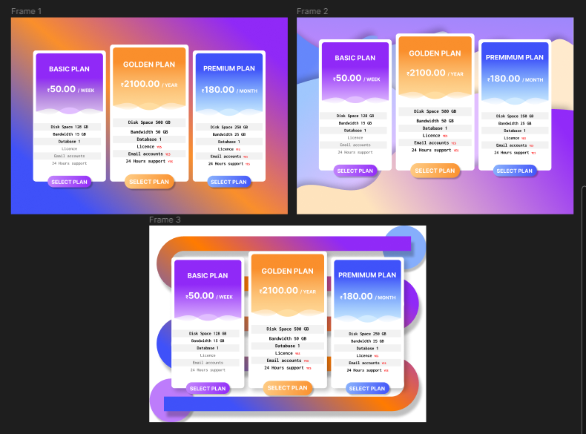

**Steps:**

* First Open Figma in browser mode.
* Then create the new document **File à New Figma Design.**
* Now add one frame using the Frame tool with width=”**950px”** and height=”**675px”** on your canvas.
* **To make Gradient Background: -**
* Get frame width=**”950px”** and height=**”675px”** fill linear color “#**9029F7**”, “#**FA8F2B**” and “#**3F51F9**”.
* Add Subscription Plan design.
* **To make Wave Background: -**
* Get frame of width=**”950px”** and height=**”675px”**.
* Now draw different wave shapes with a pan and fill the linear color of “#**912AF8**”, ”#FEE**3BD**” and “#**6587FB**”.
* Give it the effect **Drop Shadow** with X=”**-10**”, Y=”**-10**” and blur= “**25**”.
* **To make Pattern Background: -**
* Get frame width=**”950px”** and height=**”675px”**.
* Now draw the vertical wave shape with a line tool with the height=”**50” and** fill the linear color of “#**912AF8**”,” # **FEE3BD**” and “#**6587FB**”.
* Give it the effect **Drop Shadow** with X=”**10**”, Y=”**20**” and blur= “**10**”.
* Draw two ellipses of width=**”150px”** and height=**”150px”** fill one ellipse “#**86AEFC**”and fill the second ellipse “#**BD7CFB**”.
* Give the ellipse effect **Drop Shadow** with X=”**5**”, Y=”**10**” and blur= “**5**”.
* Now, Go to the **Export** button in the property panel. And **Export** it with .**JPG/.PNG** format.